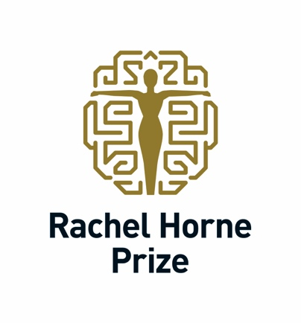

APPLICATIONS OPEN FOR INTERNATIONAL PRIZE RECOGNISING A ‘RISING STAR’ FEMALE SCIENTIST IN MULTIPLE SCLEROSIS RESEARCH

Submissions for the 2025 Rachel Horne Prize for Women’s Research in MS are now open.

This year’s prestigious US$40,000 award will honour an early to mid-career female scientist for their outstanding contribution to women’s health-related research in multiple sclerosis (MS).

“Previous recipients of the Rachel Horne Prize have been senior, established researchers who have dedicated their careers to improving women’s care in MS. This year, we decided to broaden the scope of the award and honour a ‘rising star’ in the field – a neuroscientist in her early to mid-career who has already demonstrated exceptional potential and achievements,” said Rachel Horne, founder of the award.

Applicants must be an MD, or have been awarded a PhD in the past one to ten years. At the time of submission, applicants should hold an academic rank no higher than assistant professor level. Applicants should identify as female. There are no specific requirements in respect of residency or citizenship.

Applications consist of a two-page submission in English covering
- The applicant’s career context
- Why they should be considered for the 2025 early to mid-career Prize
- What they have accomplished
- How they see the field evolving
- What are the next steps in MS research

If applicants have a PhD, they must declare the number of years post-PhD and the number of years in equivalent of assistant professor position.

Nominators are to include a statement and verifiable evidence justifying why the applicant is considered a ‘rising star’ in advancing the understanding of women’s health-related issues in MS.

Full details of the application process can be found by registering on the online application portal. The deadline for submitting applications is 10 June 2025.

The review panel will include members of International Women in MS (iWiMS). The winner will be presented with the award at the 41st Congress of the European Committee for Treatment and Research in Multiple Sclerosis (ECTRIMS) and the 30th Conference of Rehabilitation in Multiple Sclerosis (RIMS) in Barcelona, Spain in September 2025.

The prize of US$40,000 is to be used at the discretion of the recipient. It is made possible by the generosity of the Horne Family Charitable Foundation and is supported by iWiMS, ECTRIMS, and the Americas Committee for the Treatment and Research in MS (ACTRIMS).

“iWiMS is delighted to partner with the Rachel Horne Prize in recognising the outstanding contributions being made by early to mid-career women scientists,” says Marwa Kaisey MD, Chair of iWiMS. “Supporting the work of women researchers in MS is essential to fostering new perspectives and ensuring equitable representation in scientific advancements that improve patient care and outcomes.”

Last year’s prize was awarded to Dr Kerstin Hellwig for her pioneering work in improving the understanding, safety and healthcare for women with MS before, during and after pregnancy.

The 2023 Rachel Horne Prize was presented to Dr Rhonda Voskuhl for her work looking at sexual differences in susceptibility and progression in MS and identifying potential therapies to improve outcomes.

EDITOR’S NOTES
ONLINE PRESENCE
www.rachelhorneprize.com
 @RachelHorne19 #RachelHornePrize #WomenInMSMatter
 Rachel Horne

ABOUT RACHEL HORNE
Rachel Horne was diagnosed with multiple sclerosis in 2009. Drawing on her journalism background, she began researching the disease from a patient perspective and realised how little information existed about specific women’s health issues in MS – even though women make up two thirds of the people diagnosed with the disease.

She was also struck by how few women neurologists and scientists in MS were recognised for their research. In response, she set up the Rachel Horne Prize for Women’s Research in MS in 2022 through the Horne Family Charitable Foundation in Canada which was established by her father in 2010 “to do good in the world”.

ABOUT THE HORNE FAMILY CHARITABLE FOUNDATION
This prize, made possible by the generosity of the Horne Family Charitable Foundation, is to be used at the discretion of the recipient. The Horne family believes in the importance of philanthropy to shape our world. It was this belief which led Stuart Horne to set up the Horne Family Charitable Foundation following his death in 2010. The family foundation is administered by Aqueduct Foundation, which is based in Vancouver, Canada. Aqueduct is a cause-neutral Canadian registered charity with donor advised granting and specialized charitable programs in education, the arts and the environment.
www.aqueductfoundation.ca

ABOUT iWiMS
The International Women in Multiple Sclerosis network unites clinicians and researchers committed to advancing scientific discoveries and improving care for people with MS and related disorders. Founded by women and supportive of all, iWiMS advocates for meritocracy, diversity, parity, and ingenuity in MS research and patient care.
www.iwims.world

ABOUT ECTRIMS
The European Committee for Treatment and Research in Multiple Sclerosis is a non-profit, independent, representative European-wide organisation that serves as Europe’s and the world’s largest professional organisation dedicated to the understanding and treatment of multiple sclerosis.
www.ectrims.eu

ABOUT ACTRIMS
Americas Committee for Treatment and Research in Multiple Sclerosis is a community of leaders from the United States and Canada who are dedicated to the treatment and research in MS and other demyelinating diseases. ACTRIMS focuses on knowledge dissemination, education and collaboration among disciplines.
www.actrims.org

